Nopcommerce in mysql server

* Create two virtual machines one as dbserver and other as nop
* Consider one as database server and install mysql server
* Steps: [Refer Here](https://www.digitalocean.com/community/tutorials/how-to-install-mysql-on-ubuntu-20-04)  
  sudo apt update  
  sudo apt install mysql-server  
  sudo mysql



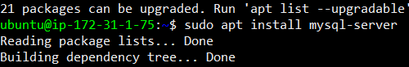

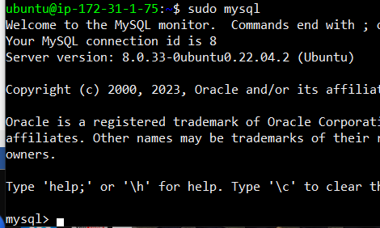

* In the mysql shell try to execute following commands  
  CREATE USER 'nop'@'localhost' IDENTIFIED BY 'nop12345';  
  GRANT ALL PRIVILEGES ON *.* TO 'nop'@'localhost';  
  FLUSH PRIVILEGES;  
  exit





 

* To verify the nop execute  mysql -u nop -p  enter password and you should be allowed in sql shell

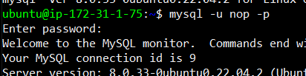

* Execute underlined commands

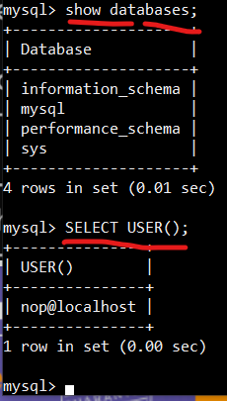

* Now install .net7 core in nop vm “ REFER HERE: <https://docs.nopcommerce.com/en/installation-and-upgrading/installing-nopcommerce/installing-on-linux.html> ”

“NOTE”

* Execute the below commands to install .net7 for ubuntu 22.4version

wget [https://packages.microsoft.com/config/ubuntu/22.04/packages-microsoft-prod.deb -O packages-microsoft-prod.deb](https://packages.microsoft.com/config/ubuntu/22.04/packages-microsoft-prod.deb%20-O%20packages-microsoft-prod.deb)

sudo dpkg -i packages-microsoft-prod.deb

rm packages-microsoft-prod.deb



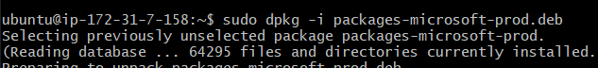



* Now execute the below commands
* sudo apt-get update && \

sudo apt-get install -y dotnet-sdk-7.0



* For Ubuntu 22.04 command to install dotnet7
* sudo apt-get update && \

sudo apt-get install -y dotnet-sdk-7.0

* Check dotnet version “ dotnet --help”

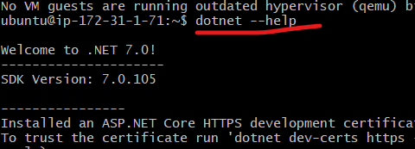

* install unzip in nop node

sudo apt install unzip –y



* Execute the below commands to install nopcommerce

sudo mkdir /usr/share/nopCommerce  
cd /usr/share/nopCommerce/  
sudo wget https://github.com/nopSolutions/nopCommerce/releases/download/release-4.60.3/nopCommerce_4.60.3_NoSource_linux_x64.zip  
sudo unzip nopCommerce_4.60.3_NoSource_linux_x64.zip  
sudo mkdir bin  
sudo mkdir logs

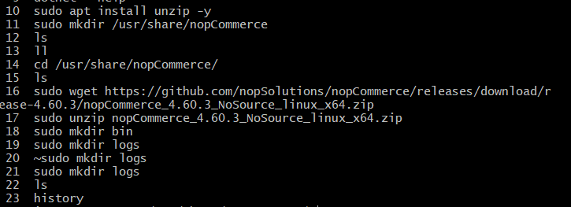

* To check nop is working or not
* sudo /usr/bin/dotnet Nop.Web.dll --urls "http://0.0.0.0:5000" 
* Enter http://<public ip>:5000 in url path

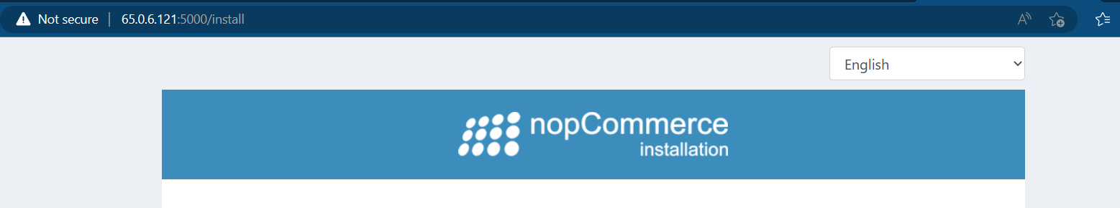

* Create a user called as nop

sudo adduser nop



* Give full permissions to /usr/share/nopCommerce to nop

sudo chgrp -R nop /usr/share/nopCommerce/

sudo chown -R nop /usr/share/nopCommerce/

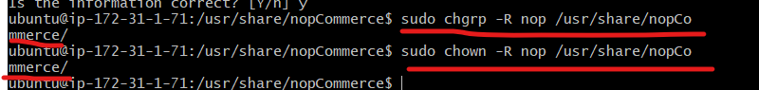

* Create a file in /etc/systemd/system/nopCommerce.service with following content

[Unit]

Description=Example nopCommerce app running on Xubuntu

[Service]

WorkingDirectory=/usr/share/nopCommerce

ExecStart=/usr/bin/dotnet /usr/share/nopCommerce/Nop.Web.dll

Restart=always

# Restart service after 10 seconds if the dotnet service crashes:

RestartSec=10

KillSignal=SIGINT

SyslogIdentifier=nopCommerce-example

User=nop

Environment=ASPNETCORE_ENVIRONMENT=Production

Environment=ASPNETCORE_URLS=http://0.0.0.0:5000

Environment=DOTNET_PRINT_TELEMETRY_MESSAGE=false

[Install]

WantedBy=multi-user.target



* Now execute

sudo systemctl enable nopCommerce.service

sudo systemctl start nopCommerce.service

sudo systemctl status nopCommerce.service

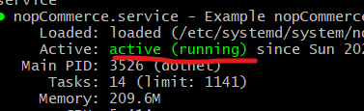

* Now access the application using http://:5000

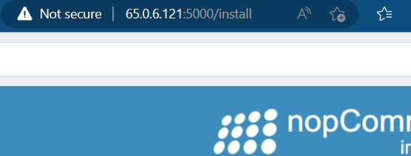

* Now move to dbserver vm
* Step 1:

The first thing we must do is configure MySQL for remote connections. To do this, log into your MySQL database server and open the configuration file with the command:

sudo vi /etc/mysql/mysql.conf.d/mysqld.cnf

In that file, look for the line:

bind-address = 127.0.0.1

Change that line to:

bind-address = 0.0.0.0

Save and close the file. Restart the MySQL service with:

sudo systemctl restart mysql

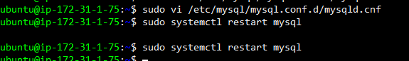

* Step 2: launch mysql shell sudo mysql



CREATE USER 'nop'@'%' IDENTIFIED BY 'nop12345';

GRANT ALL PRIVILEGES ON *.* to 'nop'@'%';

FLUSH PRIVILEGES;

exit

